The Lingnan School

Lingnan School is a school of modern Chinese painting, originating in and around the southern city of Guangzhou (known in the West as Canton) from the mid-1900s to the early 1950s, which used the traditional Chinese ink and brush medium. The term “Lingnan” or “south of the ridges,” refers to the region corresponding to Guangdong Province today, with the capital at Guangzhou. The area was the home to many reformist thinkers and revolutionaries who eventually overthrew the last imperial dynasty, and among them were the three founders of the School: Chen Shuren (1884-1948) and the brothers Gao Jianfu (1879-1951) and Gao Qifeng (1889-1933). Unlike other modern Chinese art movements, the traditional medium was not abandoned but updated to serve Chinese modernism. While the techniques remained grounded in traditional Chinese painting, many of the subjects and visual effects were wholly new. New subjects such as spiders, airplanes, and ruins were included, and old subjects were reinvented to symbolise strong nationalist and political messages. A new sense of romanticism was achieved through the extensive use of atmospheric effects in the paintings.

All three founders of the school were followers of the Ju Lian (1828-1904), a traditional Chinese painter from outside of Guangzhou who specialized in the Bird and Flower genre, the subject of which was generally ordinary plants and animals. The most important technique they received from Ju was wugu (“boneless”), which placed great emphasis on controlling the brush in capturing the form and idea of an object (“xieyi”). Instead of an outline, colored washes in varying graduations gave form to the painted subject.

Like many young Chinese intellectuals at the time, all three individually traveled to Japan to study Western art. After years of modernization and Westernization, Meiji Japan was a natural, as well as cheap and close, choice for foreword thinking young Chinese. There they studied nationalist Nihonga styles such as the Shijo School, which appropriated the more emotionally expressive effects of European realism and romanticism while retaining traditional Japanese techniques.

It was also in Japan that these individuals were engaged in revolutionary politics. Returning home after a few years, they joined the Xinhai Revolution that overthrew the Manchu-ruled imperial dynasty in 1911. Once the nationalist revolution was achieved, the brothers turned their attention to the artistic revolution of reforming traditional Chinese art. Moving to Shanghai, they promoted Lingnan School as the “New National Painting.” The third founder, Chen Shuren, who had been climbing up the ranks of the ruling Nationalist Party, later became an important patron of the school. With the party’s decline and the Japanese invasion in WWII, the School faded back into a regional style. All three founders had many followers, many living today are still practicing in various parts of the world.

References and further reading:
Chu, C. (1998) “The Lingnan School and Its Followers: Radical Innovation in Southern China” in J. Andrews & K. Shen, (eds.) A Century In Crisis: Modernity and Tradition in the Art of Twentieth-Century China.. New York, NY: Guggenheim Museum Publications.

Chu, C. and Tam, L.C.S. (1981) The Art of Gao Qifeng. Hong Kong: Urban Council Hong Kong.

Crozier, Ralph. (1988) Art and Revolution in Modern China: Lingnan (Cantonese) School of Painting, 1906-1951. Berkley, CA: University of California Press. [overview of the Lingnan School and the founder’s involvement in politics]

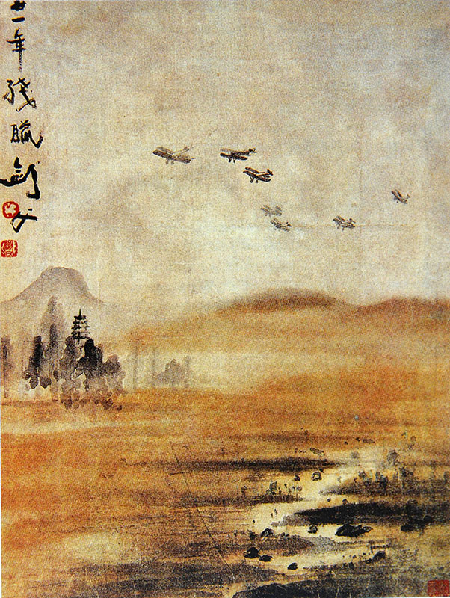
Gao Jianfu, Flying in the Rain, 1932 Ink and color on paper, hanging scroll. Art Gallery of the Institute of Chinese Studies, Chinese University of Hong Kong.

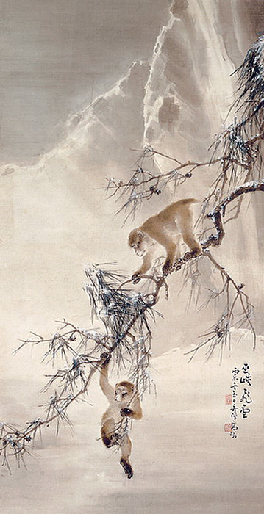
Gao Qifeng, Monkeys and Snowy Pine. Ink and color on paper, hanging scroll. Hong Kong Heritage Museum.
http://www.artslant.com/global/artists/show/274502-gao-qifeng

